**AGENCY STORIES**

This CASA has been the child's Advocate for 4 years! With no visitors allowed on the facility’s campus where the child is placed, the CASA had to discontinue her regular visits, a commitment she had maintained consistently for all these years no matter where the child was placed. In lieu of visits to the facility, the CASA began calling the child several times each week, checking in on the kid's needs, and providing a comforting voice – and ear – during scary times. When the fog of COVID-19 finally lifts, the CASA hopes to coordinate a visit between the kid and members of her distant family living out of state, who have the potential of providing the child with the forever home she has been waiting for.

This CASA Advocate was assigned to this case in 2016. She has truly been the one constant for this child. At the last hearing, the judge approved that CFSD proceed with the adoption by his caregiver, as the Advocate has recommended for years! This Advocate has been essential to the outcome of this case. She always listens to the child and has always been there for him; she facilitated other relationships that would be in the best interest of the child, such as with therapists and teachers, as the child was moved form place to place. At times when the child had nervous breakdowns or behavioral issues, the Advocate was the only person the kid would talk to.

Diversion Fund - A Mother and her children, who were fleeing domestic violence, were stuck and facing homelessness.  They had a safe place to stay with family in another state but were stuck here due to lack of gas money and a broken down car.  A local auto shop donated time to fix their car and the UWYC Diversion Fund provided gas money.  Because of this quick action, the family is now headed to a safe place where they will be supported to heal and start a better life.

HRDC

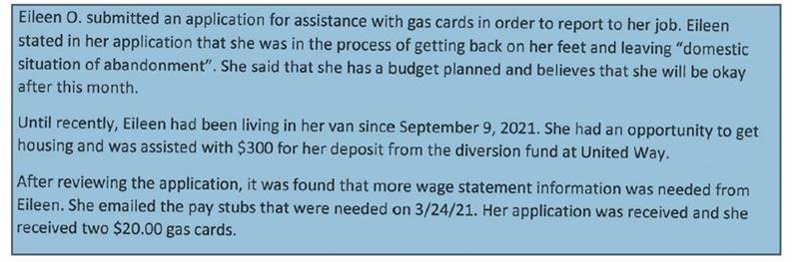

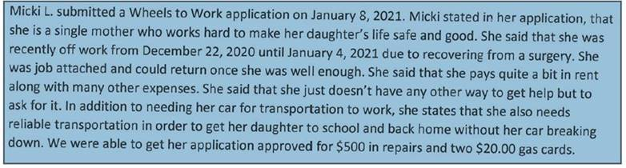

YWCA

Felicity called us while in hiding from human traffickers. She was homeless, terrified to be outside for fear of being abducted, and in desperate need to get to where her family and children live. YWCA Billings worked with YWCA in her home town to connect Felicity with another agency who immediately responded to the situation. Locally we partnered with Off the Streets, who was able to provide her transportation to Helena. She has been safely reunited with her family and friends and is in a program for victims of human trafficking.

Sally was a resident at Gateway Shelter and working on finding housing. She had many barriers that prevented her from finding housing without support from YWCA. After quickly securing a full-time job, she started working with YWCA’s Housing Navigator, Madie, to find a place to live. With Madie’s help, Sally applied for Rapid Re-Housing and was able to move into Gateway Vista. After finding secure, affordable housing she was able to focus on her other goals. She is now attending YWCA’s Financial Empowerment course to become financially stable and will soon begin attending CNA classes.