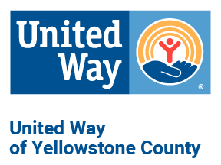

MEDIA RELEASE
MEDIA CONTACTS
Kelsie Verlin & Darcy Donahoe-Wilmot
406.272.8504 & 206.500.2828
campaign@uwyellowstone.org & darcy.donahoe-wilmot@chase.com
www.uwyellowstone.org

United Way of Yellowstone County
and JPMorgan Chase Partner Up to Create Lasting Change in Yellowstone County

United Way of Yellowstone County (UWYC) received a grant from JPMorgan Chase (JPMC) to support their programs that promote education success, financial health, advocacy, community collaboration and more. Programs that benefited from the $10,000 grant include:
School Readiness:
- Bright By Text: Educational and supportive messages are sent to busy parents directly to their phones.
- Early Childhood Literacy: Thousands of books are put in the hands of children to promote reading and lifelong learning.
School Success:
- Graduation Matters: Provides mentoring for students and promotion of school attendance.
- CARE Academy: A before and after school program that provides hundreds of elementary aged children with life skills, tutoring, and the support needed to succeed.

School readiness and school success help ensure children in Yellowstone County have the building blocks they need to become financially stable and develop skills to avoid crises when they are older. With the support from JPMC, United Way will be able to help provide learning opportunities and support to children and families in the community.

JPMC not only financially provides support for UWYC, but their employees are passionate about creating lasting change in Yellowstone County by volunteering their time. Thank you to JPMC for being an advocate for the community.

###

