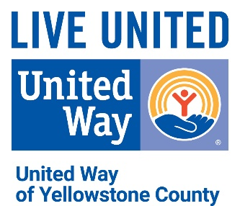

DIVERSITY, EQUITY AND INCLUSION (DEI) STATEMENT

Diversity, equity and inclusion are vital to achieving the mission of UWYC, living our values, and advancing the common good. UWYC is committed to diversity, equity and inclusion within its own organization and the community. UWYC affirms the essence of all individuals including the realities, background, experiences, skills and perspectives that make each person who they are.

UWYC aspires to involve every segment of the community in every aspect of our work, to act in ways that respect the dignity, uniqueness, and intrinsic worth of every person, the community, the donors, our own Board members, staff, volunteers and representatives, and believe in a movement built from the rich diversity and gifts of all people in all systems.

Volunteers, employees and persons served by UWYC shall be selected in a manner to promote diversity, equity and inclusion and entirely on a non-discriminatory basis with respect to race, religion, national origin, ethnicity, age, gender, gender identity and expression, disability, sexual orientation, veteran-status, familial status, or socio-economic status.

UWYC recognizes that in order to effectively engage our community, staff, volunteers, donors and community partners to achieve our community impact goals, we must embrace the diversity of the communities we serve. Our culture, recruitment, partnerships and other business practices demonstrate inclusiveness.

Board Approved: 1/28/2021

