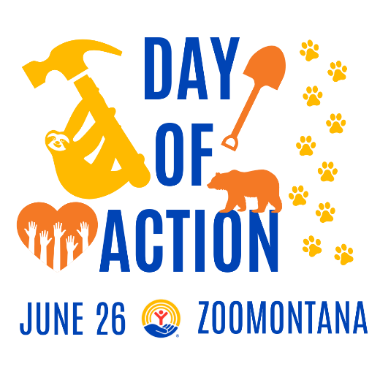

**Frequently Asked Questions**

**When will Day of Action be held?**

* Thursday June 26 from 1:00 pm – 4:30 pm. DOA may be hot and sunny or overcast and drizzling. If it appears weather will cause severe discomfort or risk of injury, it will be announced at 10am the day of.

**What is Day of Action?**

* Hosted by United Way of Yellowstone County in partnership with ZooMontana, Day of Action is a strategic volunteer program created to help advance the common good in our community.
* What is the focus? Volunteerism, fun, wellness, physical activity = togetherness.
* Promote food insecurity in our Community and asking for food donations at check in.

**Will there be a post-event celebration?**

* Yes! Starting at 5:00pm-7:00pm Meadowlark Brewing will generously be hosting a complimentary after-party, providing heavy appetizers and snacks for all participants. Meadowlark is located across from the zoo at 3970 Pierce Parkway, Billings, MT 59106.

**Why should I participate?**

* Have fun!
* Lend muscle to make a lasting, visible difference in our community.
* Day of Action isn’t just an event. It's an ongoing call to rally our community for ongoing, sustained action.
* Increase your awareness around food insecurity in our community.

**Why should local businesses participate in Day of Action?**

* Get positive exposure and generate goodwill. UWYC will highlight participating businesses in newsletters and social media posts.
* Great team-building opportunities for employees.
* Develop better relationships with potential and existing customers (you are welcome to invite customers, vendors, and your employees’ families)
* Leadership development opportunities for employees

**What do I wear?**

* Wear your company or club T-shirt. This ensures recognition for your group!
* Closed-toed shoes.
* Hat
* Sunscreen
* Gloves
* Bug Spray

**Do I need any other equipment or materials?**

* All materials and supplies will be provided.
* Wheelbarrows, saws, shovels, clippers, loppers are welcome!

**Where is ZooMontana?**

* 2100 Shiloh Rd, Billings, MT
* Free on-site parking is available.

**Things to know about this year’s Day of Action**

* It will be hot! Or it could be raining, remember we are in Montana who knows what Mother Nature has in store for us!
* Some of the activities are physically intensive.
* Working and playing outside comes with its own set of risks. To be best prepared, please wear closed-toed shoes, long pants, and a sun hat, and be prepared with water, sunscreen, and bug spray. Keep the following risks in mind:
  + Sun/heat exposure
  + Bees/wasp stings
  + Ticks
  + Mosquitoes
  + Snakes (including Rattlesnakes)
  + Uneven trails/terrain
  + Cactus
  + Poisonous plants (poison ivy, stinging nettle)

**What does UWYC provide?**

* Instructions for projects
* Water
* Roving first aid provided by RiverStone Health
* Snacks (Altana ice cream)
* Gloves

**Are there age restrictions for volunteering?**

* Individuals aged 11+ are welcome to participate. This is a great family-friendly project for older children!

**What is the average size of a team?**

* 10-12. If needed, smaller teams or individuals will be paired with others to form a team.

**What are the expectations of a Team Leader?**

* Recruit team members.
* Ensure each teammate checks in on the day of, and all teammates have registered and signs online waiver.
* Participate in 30-minute training TBD
* Give directions on site to team members.
* Distribute wristbands for the after party at Meadowlark Brewing.
* Take a team photo, post, and tag United Way of Yellowstone County!

**What is Zoo Montana?**

ZooMontana is a zoological/botanical garden, accredited arboretum and educational facility dedicated to the conservation of wildlife throughout Montana and the 45th parallel of earth. ZooMontana cares for over 100 animals of 56 different species, including Amur Tigers, Grizzly Bear, Wolverine, River Otters, Takin, and Canada Lynx, among others, most of which are rescues. ZooMontana is dedicated to the mantra “quality over quantity,” meaning the focus is not on how many animals the Zoo has, but how well those here are cared for. As one of the few Zoological parks in the country that does not receive public tax support, ZooMontana raises necessary operating funds through admissions, memberships, events and private contributions.

Located in the picturesque tourist destination of Billings Montana, ZooMontana offers visitors a unique opportunity to learn about Yellowstone ecosystem fauna through direct observation, interpretive displays, and experiential educational programs. Annually, community and educational programs serve over 18,000 students and over 150,000 visitors, most of whom hail from the northern Rockies. Led by an energetic and dynamic staff, ZooMontana enjoys strong community support through volunteerism, donations, and outreach.