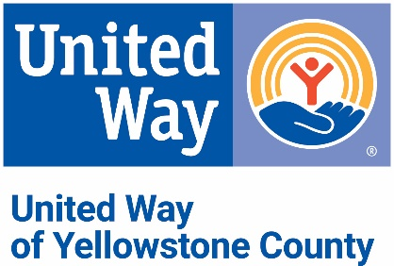**Best Practices for Special Event Contributions**

Special event funds raised in the name of United Way of Yellowstone County, by a group of employees and/or members of a business or organization, will adhere to these Best Practices:

1. Special events could include any legal means of fundraising determined by the group which may include Jeans Day, bowl-a-thon, silent auction, bake sale, raffle, or chili cook-off.
2. All Special Event Contributions will be directed to the United Way of Yellowstone County Community Care Fund.
3. All administration, solicitation of gifts for raffle or silent auction, collection of funds, expense and liability, and thank you’ s shall be borne by the organizers of the event.

**Operating Procedures**

1. Funds received by United Way of Yellowstone County from organizers of a Special Event can be in the form of:
   1. Cash
   2. Checks made payable to United Way of Yellowstone County
   3. 3rd party processors
   4. PayPal (@United Way of Yellowstone County)
   5. Customized company landing page. (Please let United Way know if you would like a webpage to be set up for your Special Event donations, in conjunction with your Workplace Giving Campaign landing page.)
2. United Way of Yellowstone County may receipt donors who have contributed items valued at least $100 for an event, such as a silent auction or raffle, provided the following information is supplied in the form of an EXCEL spreadsheet – Name of donor, complete address, description of contribution, and donor’s estimated value of contribution.