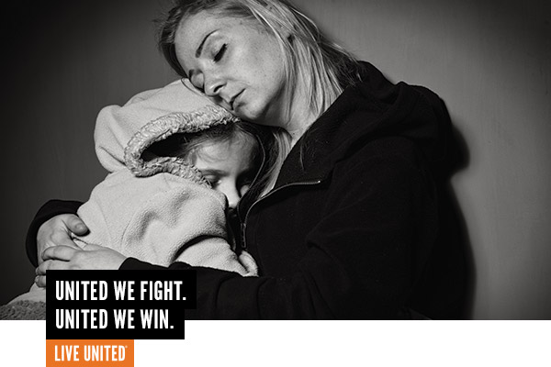

653 Homeless Students in Billings Public Schools
622 Abused and Neglected Children in Yellowstone County
18,000 Food Insecure People in Yellowstone County
Join the FIGHT.
United Way and their partners fight to ensure that no one in Yellowstone County is hungry, homeless, abused, battered, or neglected so they can achieve their full potential.

We WIN by Living United.
In 2018, United Way and their partners gave, advocated, and volunteered for vulnerable seniors, battered woman, families in crisis, homeless youth, abused children, and those desperately seeking help who did not know where to turn.

With the help of 2,232 donors like you:
- Over 11,000 households and individuals received help with food, housing and transportation.
- 96% of those receiving transportation support maintained employment because of this help.
- 98% of foster care children with a CASA advocate did not re-enter the system.
- Over 291 abused women and children found safe temporary housing

UWYC’s work is backed by years of research and knowledge gained in partnership with area and national experts – they know what works. Unfortunately, most programs and services in Yellowstone County can only serve a small percentage of the population who needs their help. But if they had the means, UWYC has done the background work to expand and sustain services right now!

Your contribution to United Way of Yellowstone County is a LIFELINE for those in crisis.
Judy and Adam struggled with substance abuse addiction on-and-off since their teen years. They have been able to maintain sobriety in the past but the stress of lacking a high school diploma, only being able to secure part-time and minimum wage jobs, having young children, and lacking the support from sober friends and family found them at their lowest point. Two years ago, Judy and Adam’s children were in separate foster homes due to their inability to secure safe housing. When they were connected with a service provider utilizing the Continuum of Care’s coordinated entry system, Judy and Adam were able to find the services they needed to earn their GED’s, find solid support systems to maintain sobriety, secure jobs that used their strengths and afforded them to be stably housed and regain custody of their children. Judy and Adam have a bright future ahead of them thanks to the generosity of donors who choose to give to United Way of Yellowstone County to support the Continuum of Care coalition’s work.

Join the fight by contributing to the United Way of Yellowstone County 2019 Annual Campaign.
(what’s raised here, stays here!)

