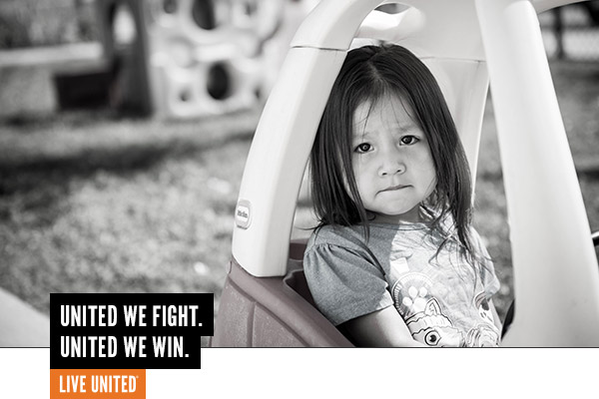

1,940 Children Age 0-5 Live in Poverty
361 Children Age 0-5 in Foster Care Due to Abuse and Neglect

Join the FIGHT.
United Way and their partners fight for our youngest children whose earliest years are more of a nightmare than a lullaby. No time is more critical in a child’s development than the prenatal years to age 5. During those ages – last year in our community -- over 1,900 children experienced the daily traumas of poverty; over 360 ended up in foster care due to abuse and neglect. Countless others lived in shelters and depended on the kindness of strangers for food. It is well known that when poverty begins in childhood, its effects last a lifetime. United Way fights to change the odds.

We WIN by Living United.
In 2018, United Way and their partners worked tirelessly to help our youngest children face the stress and hardship that affect early learning. 2,232 donors made it possible for:
- Over 500 vulnerable children to receive quality childcare/preschool, and make significant development gains.
- The parents of these children to access parent training, employment support and help for their own untreated childhood trauma.
- 9,000 books to be distributed to young children and their parents to receive guidance from a physician on how to read to and positively interact with their children.
- 1,000 parents of children 5 and under are receiving parenting tips, skills and resources on their cell phones, for free, thanks to Bright By Text.
- Over 1,200 parents of newborns are receiving post-partum care thanks to the parent connect surveys.

UWYC’s work is backed by years of research and knowledge gained in partnership with area and national experts – they know what works. Unfortunately, most programs and services in Yellowstone County can only serve a small percentage of the population who needs their help. But if they had the means, UWYC has done the background work to expand and sustain services right now!

Your contribution to United Way lays the FOUNDATION for success for our most vulnerable babies and toddlers.
Reach Out and Read is an evidence-based early literacy program that incorporates books into pediatric practice. Children, ages 6 months-5 years receive age-appropriate books at well-child checkups and parents learn from their doctor how to engage in their child’s reading.

We are very grateful for the Reach Out and Read program. My son loves the variety of books and it has helped us grow our book collection. I now realize just how important story time is!
-Brittney, mother served by the Reach Out and Read program

Join the fight by contributing to the United Way of Yellowstone County 2017 Annual Campaign.
(What’s raised here, stays here!)

