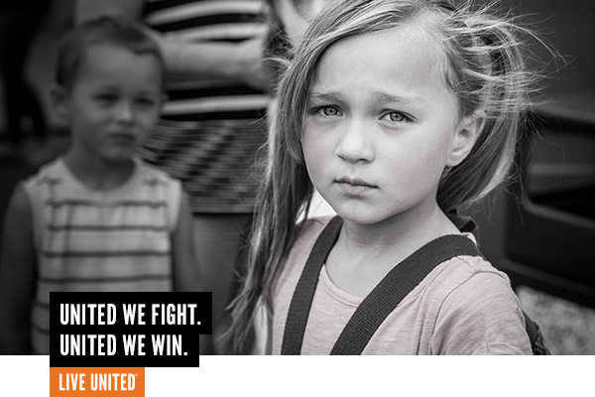

Almost ONE-THIRD of low income students in Billings Did NOT graduate with their class in 2016.

JOIN THE FIGHT.

United Way and their partners confront the big obstacles that keep low income students from a self-sufficient, hopeful future – childhood trauma and dropping out before high school graduation.

We WIN by Living United.
In 2016, United Way and their partners dug deep to provide the stability and support future graduates need to get to school every day, on time and to thrive during non-school hours. For some, this is counseling, a mentor or food. For others it’s an out-of-school time program, extra reading support or support for their parents.
In 2018, 2,232 donors ensured that:
- More than 1,500 children received empowering services.
- 90% of teen parents at Young Families Early Head Start graduated high school – Compared to less than half nationwide.
- 235 children were uplifted by 5,500 hours of mentoring.
- 74% of children in Friendship House’s reading program were reading at grade level – Compared to 36% at nearby elementary schools.

UWYC’s work is backed by years of research and knowledge gained in partnership with area and national experts – they know what works. Unfortunately, most programs and services in Yellowstone County can only serve a small percentage of the population who needs their help. But if they had the means, UWYC has done the background work to expand and sustain services right now!

Your contribution to United Way builds a BRIDGE between a traumatic past and a hopeful future. Sarah is a fifth-grader. She was frequently missing school until her United Way Success Mentor helped her start tracking her attendance and setting goals to earn incentives. Although she faltered at first, she persevered, met her goals and earned treats and lunches from her favorite restaurants as rewards for her hard work. She also gained the understanding that keeping on track with attendance helps her have less missing assignments, which in turn helps her succeed in school.

Join the fight by contributing to the United Way of Yellowstone County 2017 Annual Campaign.
(What’s raised here, stays here!)

