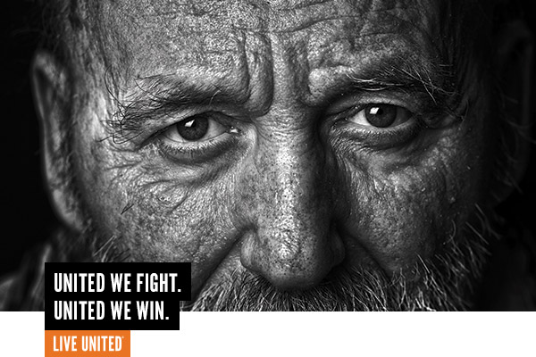

The senior population in Billings is growing faster than the population of working age individuals.

Join the FIGHT.
United Way and their partners fight for quality of life for seniors who struggle to keep food on the table, a roof over their heads and have little-to-no support system. Imagine your grandma, alone, with no one to check on her with dwindling finances. She is choosing between buying food and buying medicine. She’s not able to change a lightbulb, but has no one to call. She fell in the bathtub because she really needed a railing but had no means to put one in…. These seniors live all over Yellowstone County, and they are increasing in number.

We WIN by Living United.
In 2018, United Way and their partners gave, advocated, and volunteered to help these vulnerable seniors remain independent in their own homes, preventing the need for higher levels of care. 2,232 donors ensured that seniors received:
  - 865 seniors received support to remain independent and in their homes.
  - 4,011 hours of case management for 108 seniors through Big Sky Senior Services.
  - 7,521 hours of home service and respite care for 226 seniors.
  - 65,995 meals to homebound seniors through Adult Resource Alliance.
  - Support that increased their quality of life while decreasing costs.

UWYC’s work is backed by years of research and knowledge gained in partnership with area and national experts – they know what works. Unfortunately, most programs and services in Yellowstone County can only serve a small percentage of the population who needs their help. But if they had the means, UWYC has done the background work to expand and sustain services right now!

Your contribution to United Way makes the difference between destitution and dignity for so many seniors in our community.

"Knowing someone is coming to check on me gives me something to look forward to. I feel much less alone knowing they are coming. The hot meal is just a plus.” – Senior receiving services from a UWYC partner
Join the fight by contributing to the United Way of Yellowstone County 2019 Annual Campaign.
(What’s raised here, stays here!)

