Donor Email Templates

Below is customizable text and copy for eight donor emails, with banner images sized accordingly. Here is an overview of what is included:

* Welcome
  + 1a. Workplace campaign kickoff
  + 1b. Company CEO welcome
* Why United Way?
  + 2: Our value-add
* Reminders
  + 3a. Impact
  + 3b. Great things we do together
  + 3c. Time is running out!
* Thank You (post- campaign)
  + 4a. General thank you to all employees, with campaign stats.
  + 4b. Thank you to donors, with review of United Way impact. This can bridge the individual engagement theme (Leading the Way) and tee up additional engagement opportunities.

**Email 1a: Campaign Welcome and Kick-Off**

**From:** Corporate CEO or ECC

**Audience:** All company employees

**Call to Action**: Give now to join the campaign

**Image**: Use below, select one of your own images, select an image from the Campaign Toolkit

**Subject Line:** Leading the Way in Yellowstone County

**Preheader Text:** In our community, everyone deserves the opportunity to thrive.

**Email Body:**

[Name],

Join [Company Name] in leading the way for a better future for all by donating today.

Your support of United Way of Yellowstone County will allow us to advance health, youth opportunity, financial security to ensure our neighbors can thrive. Our work is powered by generous supporters, like you and [Company Name], who are committed to #LeadingTheWay to a stronger community.

Because of your generous support, United Way of Yellowstone County is making a difference in the lives of thousands of people every year. Donate today and join us in Leading the Way to a better future for all.

**Click here to learn more:** [LEAD THE WAY](https://www.unitedwayyellowstone.org/our-impact)

Closing,  
*Signature*

*P.S. Pictured - United for a Better Community – over 180 volunteers making a difference together.*

**Email 1b: Company CEO variation**

**From: Your** Company CEO, Leader, or Employee Campaign Chair’s first and last name

**Audience:** All company employees

**Call to Action**: Give now to join the campaign

**Image**: Use below, select one of your own images, select an image from the Campaign Toolkit

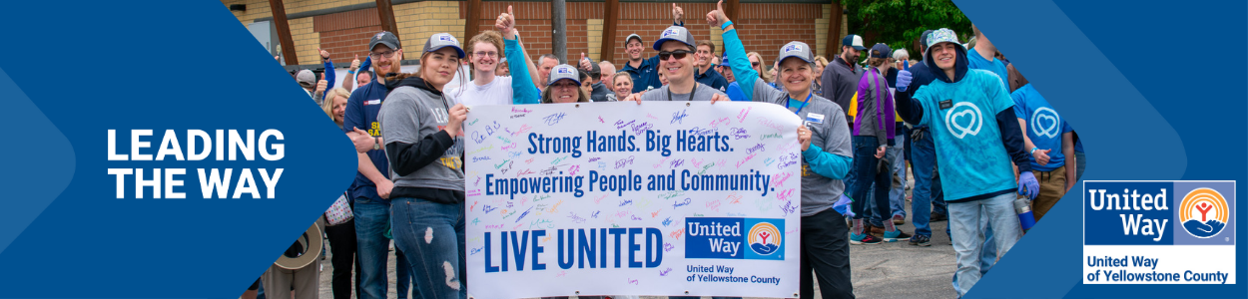

**Subject Line:** [Company Name] is Leading the Way in Yellowstone County  
**Preheader Text:** In our community, everyone deserves the opportunity to thrive.  
**Email Body:**

[Name],

United Way of Yellowstone County supports the needs of our community every day to help strengthen our community to ensure everyone will thrive. *Join me in leading the way for our community by participating in this year’s campaign.* We’ve set an ambitious goal of raising *[monetary goal/description*]to help do just that.

I believe that when we come together as a team, there’s no challenge that can’t be solved. That’s why I’m inviting you to join me in Leading the Way toward positive change in Yellowstone County. This is more than a campaign – it is a call to action for us at [Company Name] to advance solutions to real problems facing people in the communities where we live and work.

[Share your why]

Together, we can advance health, youth opportunity, financial security and strengthen overall community resilience to build a future where everyone can reach their full potential. We’re counting on generous people like you and your teammates to help improve the lives of people in our community. This year, United Way of Yellowstone County awarded $300,000 to 15 selected Partner Grant Agencies in the areas of School Readiness, School Success, Crisis Stabilization, and Senior Independence. The transition to annual grants underscores our commitment to community responsiveness for vulnerable populations, with our support. And this year, with your help, we know that we can do even more.

You can make your donations here: LEAD THE WAY (Insert your United Way Campaign landing page)

I want to thank you in advance for your valuable support and for Leading the Way here at [Company Name].

[Closing],  
*Signature*

*P.S. Pictured - Together We Thrive- Community volunteers transforming our parks and supporting mental health.*

**Email 2:**

**From:** Corporate CEO or ECC  
**Audience:** All company employees  
**Call to Action:** There’s still time to give now and join the campaign

**Image**: Use below, select one of your own images, select an image from the Campaign Toolkit

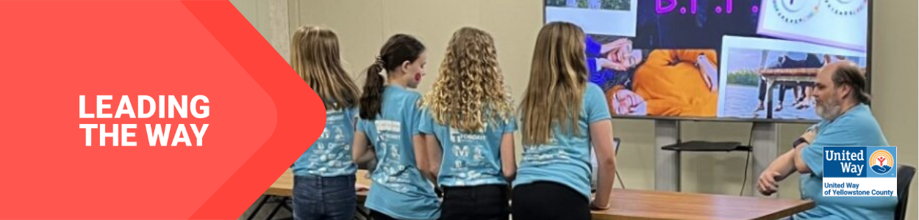

**Subject Line:** Lead the Way in Yellowstone County

**Preheader Text:** What makes United Way of Yellowstone County so special?

**Email Body:**

Dear [First name],

United Way of Yellowstone County mobilizes communities to action so that all can thrive. Whenever there’s a need in our community, United Way is there. Yellowstone County is all about creating a future where everyone, everywhere can rise. And thanks to people like you, we positively impacted thousands of people last year alone.

And we’re not stopping there. Your support can help continue tackling the biggest problems in Yellowstone County. From education and health to hunger and natural disasters, we bring a comprehensive approach to every challenge. Because more than 63 years of experience has shown us that when people unite to take action, change is possible.

Donate today. Join us in Leading the Way to a better future for all.

LEAD THE WAY! [DONATE HERE](https://www.unitedwayyellowstone.org/ways2give)! (Insert your United Way Campaign landing page)

[Closing],  
*Signature*

*P.S. Pictured – Innovating the Future – Meadowlark CARE Academy kiddos shining in Code Girls United.*

**Reminder Emails**

Depending on the length of your campaign, we recommend sending one reminder email per week. Below are three sample emails, which can be customized to your United Way, and your relationship with that workplace.

* **3a. Impact.** We’ve offered one email with several opportunities to talk about your impact, but you can make this multiple emails, or center it on just one area of your work that fits most closely with the Company’s community service/impact goals.
* **3b. Great things we do together.** Use this one to highlight special activities you’ve done with donors, like Day of Action/Caring/Service, or volunteer projects they’ve completed.
* **3c. Time is running out!** You may choose to send this starting 10 days, one week or one day out, depending on what makes the most sense for your campaign and relationship with the company.

**Email 3a: Reminder #1**

**From:** Corporate CEO or ECC

**Audience:** All company employees  
 **Call to Action:** Join the campaign by donating

**Image**: Use below, select one of your own images, select an image from the Campaign Toolkit

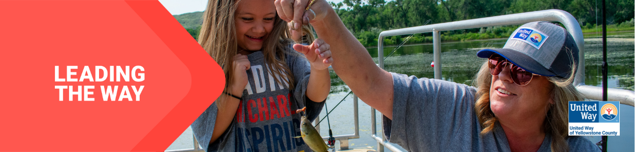

**Subject Line:** What are we doing together in [Anytown]?

**Preheader Text:** Mobilizing our community and changing lives.

**Email Body:**

Hi [Name],

We need you with us-- whether you’re new to United Way of Yellowstone County or you’ve been creating impact with us for years.

At United Way, we believe that everyone who lives and works in Yellowstone County deserves the opportunity to thrive. Together with you and partners like [Company Name], United Way mobilizes the caring power of people to create transformational change here in Yellowstone County.

Day in and day out, United Way of Yellowstone Countyfunds, leads and developsprograms that meet the most urgent needs in our community, which includes all of Yellowstone County*.* We’re proud of all we’ve accomplished together for our great community:

This year, United Way of Yellowstone County awarded $300,000 to 15 selected Partner Grant Agencies in the areas of School Readiness, School Success, Crisis Stabilization, and Senior Independence. The transition to annual grants underscores our commitment to community responsiveness for vulnerable populations, with our support. And this year, with your help, we know that we can do even more.

To be nimble and responsive to community need, UWYC transitioned from multi-year grants to annual grants. Grants were awarded to organizations and programs that address United Way’s initiatives that directly impact school readiness, school success, crisis stabilization, and senior independence efforts for high-risk and vulnerable populations in Yellowstone County. We are proud to partner with organizations focusing on improving our community, and supporting programs for some of our most vulnerable populations ensures better health, better care and better communities.

More work is needed to build on this momentum. If you’ve already given, thank you. If you haven’t, there’s still time to join in.

**BUTTON TEXT:** Donate [HERE](https://www.unitedwayyellowstone.org/ways2give)

Together, let’s Lead the Way and make great things for people who call Yellowstone County home.

[Closing],  
*Signature*

*P.S. Pictured - Casting for Success – Volunteers teaching kiddos the joys of fishing and outdoor skills.*

**Email 3b: Reminder #2**

**From:** Corporate CEO or ECC  
 **Audience:** All company employees  
 **Call to Action:** Join the campaign by donating

**Image**: Use below, select one of your own images, select an image from the Campaign Toolkit

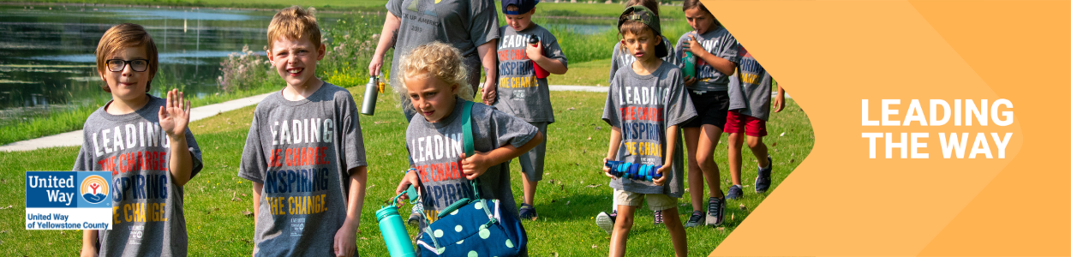  
*Click* [*here*](https://www.canva.com/design/DAGFc7D572w/HYfQvy-UpDF-vc3gLkL57Q/view?utm_content=DAGFc7D572w&utm_campaign=designshare&utm_medium=link&utm_source=publishsharelink&mode=preview) *for the Canva template*

**Subject Line:** How United Way and [Company Name] are Leading the Way

**Preheader Text:** Partnered up to create real impact

**Email Body:**

Dear [Name],

We want to take a moment to celebrate how United Way of Yellowstone County and [Company Name] are partnering to change lives in our community.

Thanks to [Company Name]’s support and people like you…

*[This email should be tailored to your relationship with the company. We suggest:*

*Highlight the number of years a company has been a sponsor*

*Highlight the impact the company has had during your Day of Action—the # of hours, the value of that volunteer service to the community. How United Way has helped deepen the company culture around service. Add photos from Day of Action, if you have releases.*

*Has the company done food drives or holiday drives through United Way to benefit the community?*

*Does the company have a number of hours of volunteerism to celebrate?]*

Let’s build on [Company Name]’s legacy to do even more. Donate today to Lead the Way to a better future for Yellowstone County.

**BUTTON TEXT:** Donate [Hyperlink]

[Closing],  
*Signature*

*P.S. Pictured – Empowering Futures Through Enriching Experiences- Our CARE Academy kiddos thrive with every outdoor adventure, showcasing the lasting economic impact of our out-of-school time programs.*

**Email 3c: Reminder #3 or Final Reminder**

**From:** Kim Lewis, President and CEO United Way of Yellowstone County  
 **Audience:** All company employees  
 **Call to Action:** Join the campaign by donating

**Image**: Use below, select one of your own images, select an image from the Campaign Toolkit

**Subject Line:** Time is running out to Lead the Way

**Preheader Text:** Tick, tock…

**Email Body:**

Have you donated yet to Lead the Way in Yellowstone County?

From strengthening local resilience to advancing youth opportunity, financial security, and community resiliency your support is integral to creating impact in our community. Employees at [Company Name] are chipping in and Leading the Way to a better future for everyone in Yellowstone County.

**Click “Donate” to make your donation today!** [Donate](https://www.unitedwayyellowstone.org/ways2give)

Thank you for your continued support!

[Name],

[Closing],  
*Signature*

*P.S. Pictured – Building a Stronger Community – Volunteers repairing fences and making a difference.*

**Email 4a: General Thank You #1**

**From:** Corporate CEO or ECC  
**Audience:** All company employees  
**Call to Action:** See your impact

**Image**: Use below, select one of your own images, select an image from the Campaign Toolkit

**Subject Line:** Thank you for Leading the Way in Yellowstone County!

**Preheader Text:** [intentionally left blank]

**Email Body:**

Dear [Name],

Join me in celebrating the success of [Company Name’s] efforts to Lead the Way by changing lives in Yellowstone County.

I’m thrilled to report [customize]

[Company Name] employees gave $ [dollars pledged] to United Way of Yellowstone County.

[participation rate%] of [Company Name] Employees gave to United Way of Yellowstone County

[number of donors] of [Company Name] employees gave to United Way of Yellowstone County

[Company Name] employees contributed more than [number of volunteer hours] volunteer hours during the campaign.

Together, our collective impact is creating a better future for youth, families and communities in Yellowstone County.

Thank you for Leading the Way!

**BUTTON TEXT:** SEE YOUR IMPACT [Hyperlink]

[Closing],  
*Signature*

*P.S. Pictured- Community Connections – CARE Staff showcasing United Way’s impact and opportunities at a local event.*

**Email 4a: Donor Thank You #2**

**From:** Corporate CEO or ECC  
**Audience:** Company employees who donated to United Way

**Call to Action:** Continue your support

**Image**: Use below, select one of your own images, select an image from the Campaign Toolkit

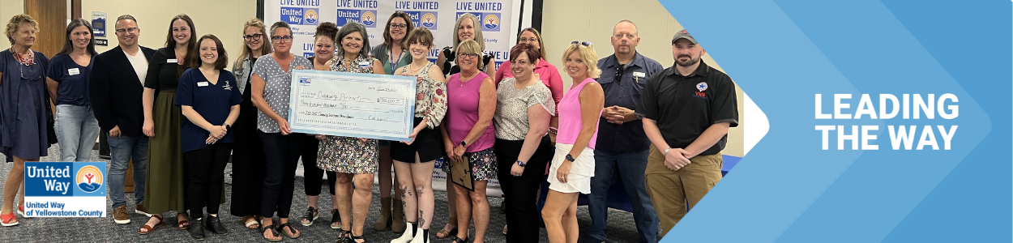  
**Subject Line:** Thank you for Leading the Way in Yellowstone County

**Email Body:**   
Dear [Name],

First, thank you for Leading the Way in Yellowstone County through your generous gift to United Way. Your donation is making a real difference in the lives of our neighbors and friends.

Today and every day, we need you with us. Here are ways that your support can continue making our community a better place:

* + **Volunteer**: Make a difference by volunteering – providing a ride to someone who’s homebound, reading to preschoolers to get them school-ready, or passing out food to neighbors in need. Consider serving on one of our community’s grant evaluation boards or offering your unique skills to a local nonprofit who needs your expertise. Find out more -> [**HERE**](https://www.unitedwayyellowstone.org/volunteer)
  + **Advocate**: Encourage your neighbors and colleagues to become active in our community and raise your voice on the issues that impact hard-working families in Yellowstone County. Join United Way’s in-person and virtual events to help every person in our region thrive.
  + **Stay in the Loop:** Signup for our email newsletter to keep informed about what’s going on across Yellowstone County. Join us! Sign up for updates -> [HERE](https://www.unitedwayyellowstone.org/sign-our-newsletter)

Thank you for your commitment to Yellowstone County. Together, let’s Lead the Way to a better future for all.

[Closing],  
*Signature*

*P.S. Pictured – Empowering Change- United Way of Yellowstone County’s President and CEO presenting grants to Community Investment Partner Agencies supporting key initiatives.*